**Load Balancer**

A load balancer accepts incoming traffic from clients and routes requests to EC2 instances (Targets).

The load balancer also monitors the health of its registered targets and ensures that it routes traffic only to healthy targets.

When the load balancer detects an unhealthy target, it stops routing traffic to that target. It then resumes routing traffic to that target when it detects that the target is healthy again.

**Step 1: Create Linux Machines**

* Launch Amazon Linux instance.
* Name the instance Lin-1.
* Create a security group named "LinSG" and add an HTTP rule that allows inbound traffic from anywhere.
* Launch

**Step 2: Access the Machines**

* Use the PPK file to connect to the Lin-1 and Lin-2 instances.

**Step 3: Install Web Package on Lin-1**

1. Connect to Lin-1.
2. As root, update the packages and install the httpd package:

sudo su

yum update -y

yum install httpd -y

1. Create an index.html file with the content:

cd /var/www/html

echo "Hi First Instance" > index.html

1. Start the httpd service and enable it to start automatically at boot:

service httpd start

chkconfig httpd on

1. Verify that the web server is running by accessing the instance's public IP address in a web browser.

**Step 4:** Launch one more Amazon Linux instance “Lin-2” and install web package.

Select existing security group and key pair. Add user data.

Advanced Details - User data

#!/bin/bash

sudo su

yum update -y

yum install httpd -y

cd /var/www/html

echo "Hi Second Instance" > index.html

service httpd start

chkconfig httpd on

**Step 5: Create a Classic Load Balancer**

1. Go to the EC2 console and select "Load Balancers" from the navigation pane.
2. Click "Create Load Balancer" and select "Classic Load Balancer".

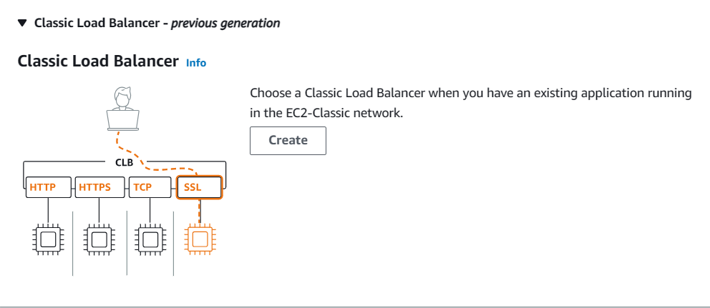

1. Enter the load balancer name, such as "MyLB".
2. Select the existing security group "LinSG".
3. Configure the advanced health check settings:

Response Timeout: 2 Seconds

Interval: 5 Seconds

Unhealthy Threshold: 2

Healthy Threshold: 2

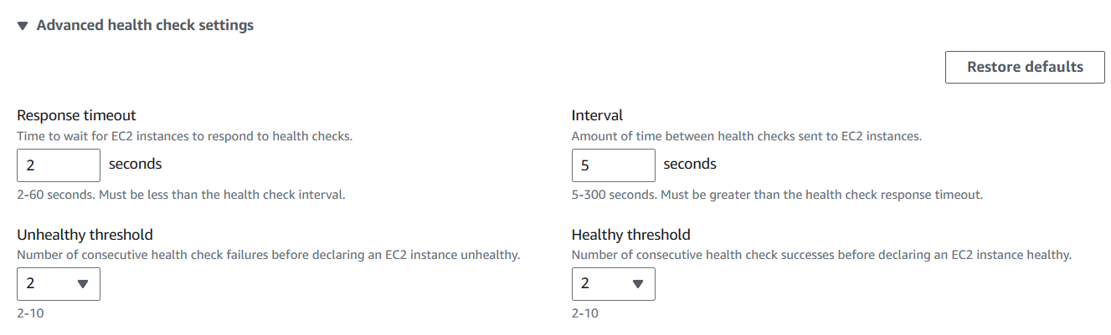

1. Select both the Lin-1 and Lin-2 instances.
2. Review the summary.
3. Click "Create" to create the load balancer.

**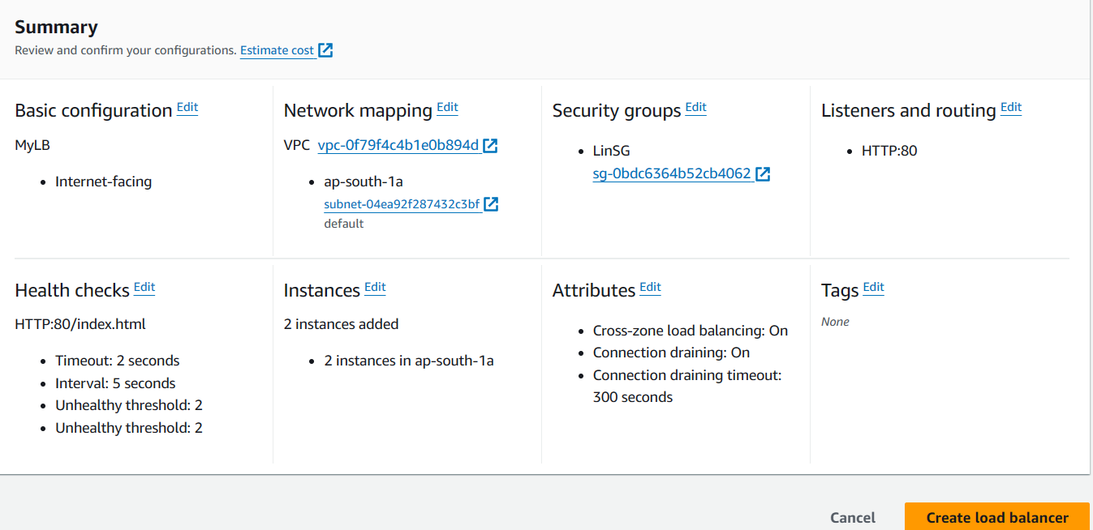  
Step 6: Verify the Load Balancer**

1. Access the load balancer's DNS name (e.g., MyLB-761818952.ap-south-1.elb.amazonaws.com) in a web browser.
2. You should see the “Hi First Instance” displayed.

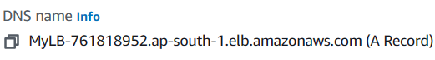

**Step 7: Test Failover**

1. Stop the Lin-1 instance.
2. Access the load balancer's DNS name again.
3. You should see "Hi Second Instance" displayed.

**Step 8: Monitor Instance Status**

1. Go to the EC2 console and select "Load Balancers" from the navigation pane.
2. Select the "MyLB" load balancer.
3. Click the "Target instances" tab.
4. You can see the status of the Lin-1 and Lin-2 instances.

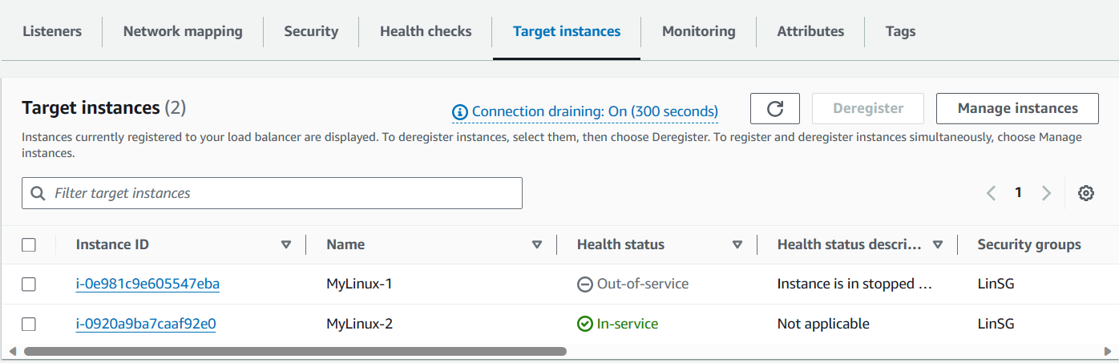

**Step 9: Delete Load Balancer and Instances**

1. To avoid billing, delete the load balancer and instances.
2. Select the "MyLB" load balancer and click "Delete".
3. Select the Lin-1 and Lin-2 instances and click "Terminate Instances".

